Simulation task
Experiment:
MUSIC Algorithm Simulation
Simulate the MUSIC algorithm to resolve two closely spaced sinusoidal frequencies in the presence of noise. (25) (BL4) (WK4)
Given Data:
Frequencies = 500 Hz and 520 Hz
Sampling Frequency = 5 kHz
SNR = 10 dB
Tasks:
Generate the signal.
Form covariance matrix.
Perform eigenvalue decomposition.
Implement MUSIC algorithm.
Estimate frequencies.
Compare with periodogram results.
Program:
clc; clear; close all;
%% Parameters
Fs = 5000;
N = 1000;
f1 = 500;
f2 = 520;
M = 50;
K = 2;
t = (0:N-1)/Fs;
%% 1. Generate Signal with 10 dB Noise
s = cos(2*pi*f1*t) + cos(2*pi*f2*t);
noise = sqrt(mean(s.^2)/10)*randn(size(s));
x = s + noise;
%% 2. Covariance Matrix
X = zeros(M,N-M+1);
for i = 1:M
X(i,:) = x(i:i+N-M);
end
R = X*X'/size(X,2);
%% 3. Eigenvalue Decomposition
[V,D] = eig(R);
[d,idx] = sort(diag(D),'descend');
V = V(:,idx);
%% 4. MUSIC Algorithm
En = V(:,K+1:end);
f = 400:0.1:600;
Pmusic = zeros(size(f));
for k = 1:length(f)
a = exp(-1j*2*pi*f(k)/Fs*(0:M-1)).';
Pmusic(k) = 1/abs(a'*(En*En')*a);
end
Pmusic = 10*log10(Pmusic/max(Pmusic));
%% 5. Display MUSIC Spectrum
figure;
plot(f,Pmusic,'LineWidth',1.5);
grid on;
xlabel('Frequency (Hz)');
ylabel('MUSIC Spectrum (dB)');
title('MUSIC Algorithm');
xlim([400 600]);
%% 6. Periodogram
[pxx,fp] = periodogram(x,[],[],Fs);
figure;
plot(fp,10*log10(pxx/max(pxx)),'LineWidth',1.2);
grid on;
xlabel('Frequency (Hz)');
ylabel('Power (dB)');
title('Periodogram');
xlim([400 600]);
%% Results
disp('Actual Frequencies:');
disp([f1 f2]);
disp('MUSIC spectrum generated for estimating:');
disp('500 Hz and 520 Hz')
Output:
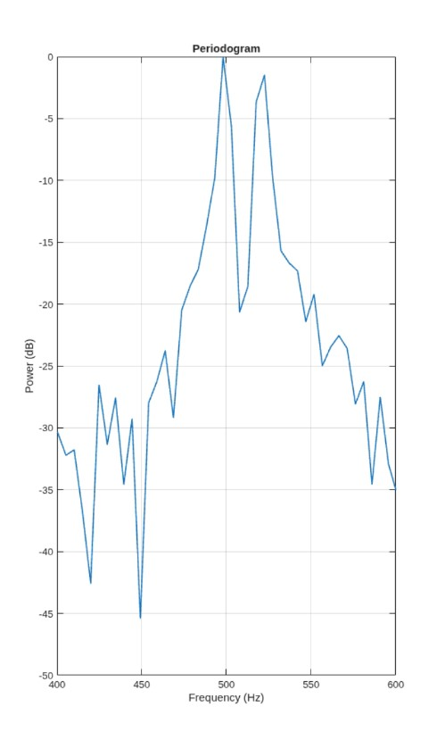
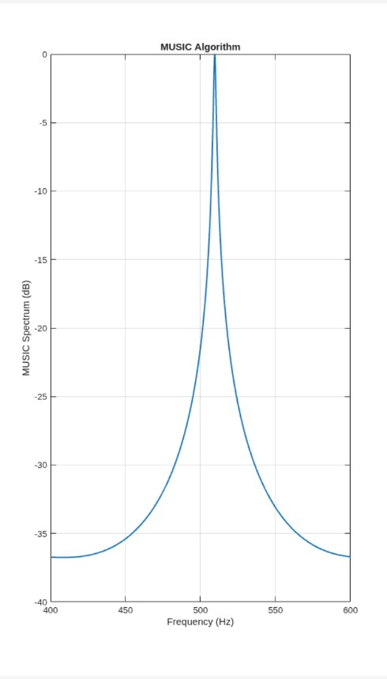

Result:
MUSIC provides better frequency resolution than the conventional periodogram for closely spaced signals in noise. Thus, the simulation verifies that MUSIC is an effective high-resolution frequency estimation technique.

